**CREDIT CARD SQL QUERRIES**

**KPI’s**

**--KPI 1: Total Customers**

select distinct COUNT (id) as total_customer

from cleaned_data;



**--KPI 2: Total Loan Amount**

SELECT

SUM(LIMIT_BAL) AS Total_Loan_Amount

FROM

Cleaned_Data;



-**-KPI 2: Total Customer by Marriage Status**

SELECT

cleaned_marraige as Marraige,

COUNT(ID) AS Customer_Count,

CAST(COUNT(ID) AS DECIMAL(10, 4)) * 100.0 / SUM(COUNT(ID)) OVER () AS Percentage_of_Total

FROM

Cleaned_Data

GROUP BY

cleaned_marraige

ORDER BY

Customer_Count DESC;

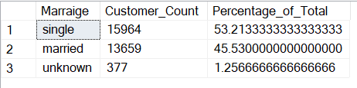

**--KPI 3:Total Customer by Age Bucket**

SELECT

age_bucket,

COUNT(ID) AS Customer_Count,

CAST(COUNT(ID) AS DECIMAL(10, 4)) * 100.0 / SUM(COUNT(ID)) OVER () AS Percentage_of_Total

FROM

Cleaned_Data

GROUP BY

age_bucket

ORDER BY

Customer_Count DESC;

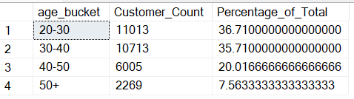

**--KPI 3: Overall portfolio Default Rate**

select

cast(sum(CASE WHEN default_payment_next_month = 1 THEN 1 ELSE 0 END) as decimal (10,4))*100/count(id) as overall_default_rate_percentage

from cleaned_data;



**--KPI 4: Average Portfolio Credit Utilization**

SELECT

CAST(SUM(BILL_AMT1) AS DECIMAL(18, 4)) * 100.0 / SUM(LIMIT_BAL) AS Average_Credit_Utilization_Percentage

FROM

Cleaned_Data

WHERE

LIMIT_BAL > 0;

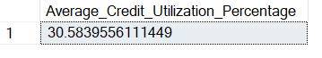

**-- KPI 5: monthly default rate (Trend Analysis)**

WITH MonthlyPaymentStatus AS (

-- Unpivoting PAY_1 to PAY_6 into a monthly structure

-- PAY_1 (April)

SELECT ID, 'April' AS Payment_Month, CASE WHEN PAY_0 >= 2 THEN 1 ELSE 0 END AS Monthly_Default_Flag FROM Cleaned_Data WHERE PAY_0 IS NOT NULL

UNION ALL

-- PAY_2 (May)

SELECT ID, 'May' AS Payment_Month, CASE WHEN PAY_2 >= 2 THEN 1 ELSE 0 END AS Monthly_Default_Flag FROM Cleaned_Data WHERE PAY_2 IS NOT NULL

UNION ALL

-- PAY_3 (June)

SELECT ID, 'June' AS Payment_Month, CASE WHEN PAY_3 >= 2 THEN 1 ELSE 0 END AS Monthly_Default_Flag FROM Cleaned_Data WHERE PAY_3 IS NOT NULL

UNION ALL

-- PAY_4 (July)

SELECT ID, 'July' AS Payment_Month, CASE WHEN PAY_4 >= 2 THEN 1 ELSE 0 END AS Monthly_Default_Flag FROM Cleaned_Data WHERE PAY_4 IS NOT NULL

UNION ALL

-- PAY_5 (August)

SELECT ID, 'August' AS Payment_Month, CASE WHEN PAY_5 >= 2 THEN 1 ELSE 0 END AS Monthly_Default_Flag FROM Cleaned_Data WHERE PAY_5 IS NOT NULL

UNION ALL

-- PAY_6 (September)

SELECT ID, 'September' AS Payment_Month, CASE WHEN PAY_6 >= 2 THEN 1 ELSE 0 END AS Monthly_Default_Flag FROM Cleaned_Data WHERE PAY_6 IS NOT NULL

)

SELECT

mps.Payment_Month,

CAST(SUM(mps.Monthly_Default_Flag) AS DECIMAL(10, 4)) * 100.0 / COUNT(mps.ID) AS Monthly_Default_Rate_Percentage

FROM

MonthlyPaymentStatus mps

GROUP BY

mps.Payment_Month

ORDER BY

CASE mps.Payment_Month

WHEN 'April' THEN 1 WHEN 'May' THEN 2 WHEN 'June' THEN 3 WHEN 'July' THEN 4 WHEN 'August' THEN 5 WHEN 'September' THEN 6 ELSE 7

END;

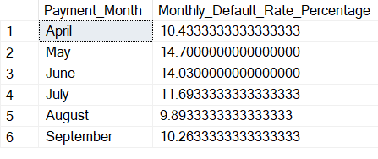

**--KPI 6: Monthly Bill amount & pay amount**

WITH MonthlyAmounts AS (

-- Unpivot BILL_AMT columns

SELECT ID, 'April' AS Month_Name, 'Bill Amount' AS Metric_Type, BILL_AMT1 AS Amount FROM Cleaned_Data UNION ALL

SELECT ID, 'May' AS Month_Name, 'Bill Amount' AS Metric_Type, BILL_AMT2 AS Amount FROM Cleaned_Data UNION ALL

SELECT ID, 'June' AS Month_Name, 'Bill Amount' AS Metric_Type, BILL_AMT3 AS Amount FROM Cleaned_Data UNION ALL

SELECT ID, 'July' AS Month_Name, 'Bill Amount' AS Metric_Type, BILL_AMT4 AS Amount FROM Cleaned_Data UNION ALL

SELECT ID, 'August' AS Month_Name, 'Bill Amount' AS Metric_Type, BILL_AMT5 AS Amount FROM Cleaned_Data UNION ALL

SELECT ID, 'September' AS Month_Name, 'Bill Amount' AS Metric_Type, BILL_AMT6 AS Amount FROM Cleaned_Data UNION ALL

-- Unpivot PAY_AMT columns

SELECT ID, 'April' AS Month_Name, 'Payment Amount' AS Metric_Type, PAY_AMT1 AS Amount FROM Cleaned_Data UNION ALL

SELECT ID, 'May' AS Month_Name, 'Payment Amount' AS Metric_Type, PAY_AMT2 AS Amount FROM Cleaned_Data UNION ALL

SELECT ID, 'June' AS Month_Name, 'Payment Amount' AS Metric_Type, PAY_AMT3 AS Amount FROM Cleaned_Data UNION ALL

SELECT ID, 'July' AS Month_Name, 'Payment Amount' AS Metric_Type, PAY_AMT4 AS Amount FROM Cleaned_Data UNION ALL

SELECT ID, 'August' AS Month_Name, 'Payment Amount' AS Metric_Type, PAY_AMT5 AS Amount FROM Cleaned_Data UNION ALL

SELECT ID, 'September' AS Month_Name, 'Payment Amount' AS Metric_Type, PAY_AMT6 AS Amount FROM Cleaned_Data

)

SELECT

ma.Month_Name,

ma.Metric_Type,

SUM(ma.Amount) AS Total_Monthly_Amount

FROM

MonthlyAmounts ma

GROUP BY

ma.Month_Name,

ma.Metric_Type

ORDER BY

CASE ma.Month_Name

WHEN 'April' THEN 1 WHEN 'May' THEN 2 WHEN 'June' THEN 3 WHEN 'July' THEN 4 WHEN 'August' THEN 5 WHEN 'September' THEN 6 ELSE 7

END,

ma.Metric_Type;  
  
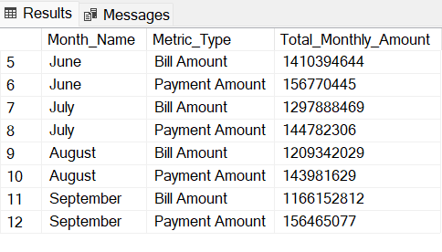

**B. DEMOGRAPHIC DEFAULT RATES**

**--1. Default rate by Gender (sex)**

select cleaned_sex,

cast (sum(case when default_payment_next_month = 1 then 1 else 0 end)as decimal (10,4))*100/COUNT(id)AS Default_Rate_Percentage

FROM

Cleaned_Data

GROUP BY

cleaned_sex

ORDER BY

cleaned_sex;

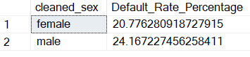

**-- 2 Default Rate by Age Group**

SELECT

age_bucket,

CAST(SUM(CASE WHEN default_payment_next_month = 1 THEN 1 ELSE 0 END) AS DECIMAL(10, 4)) * 100.0 / COUNT(ID) AS Default_Rate_Percentage

FROM

Cleaned_Data

GROUP BY

age_bucket

ORDER BY

age_bucket desc;

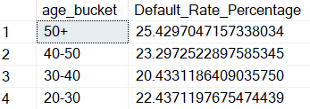

**-- 3 Default Rate by Education Segment**

SELECT

Education_segment,

CAST(SUM(CASE WHEN default_payment_next_month = 1 THEN 1 ELSE 0 END) AS DECIMAL(10, 4)) * 100.0 / COUNT(ID) AS Default_Rate_Percentage

FROM

Cleaned_Data

GROUP BY

EDUCATION_Segment

ORDER BY

EDUCATION_Segment;

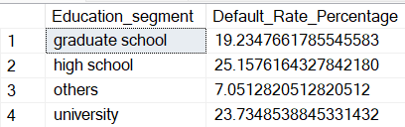

**-- 4 Default Rate by Marriage Status**

SELECT

Cleaned_marraige as Marraige,

CAST(SUM(CASE WHEN default_payment_next_month = 1 THEN 1 ELSE 0 END) AS DECIMAL(10, 4)) * 100.0 / COUNT(ID) AS Default_Rate_Percentage

FROM

Cleaned_Data

GROUP BY

cleaned_marraige

ORDER BY

cleaned_marraige;

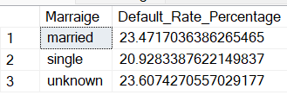

**C. BEHAVIORAL DEFAULT RATES**

**--1 Default Rate by Max Delay Segment**

SELECT

MAX_Delay_Segment,

CAST(SUM(CASE WHEN default_payment_next_month = 1 THEN 1 ELSE 0 END) AS DECIMAL(10, 4)) * 100.0 / COUNT(ID) AS Default_Rate_Percentage

FROM

Cleaned_Data

GROUP BY

MAX_Delay_Segment

ORDER BY

-- Order by a logical sequence for delay segments if not alphabetical

CASE MAX_Delay_Segment

WHEN 'No Delay' THEN 1

WHEN 'Minor Delay' THEN 2

else 3

END;

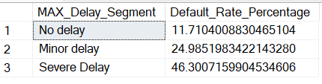

**--2 Default Rate by Delay Trend (delay_trend_0_2)**

SELECT

delay_trend_0_2,

CAST(SUM(CASE WHEN default_payment_next_month = 1 THEN 1 ELSE 0 END) AS DECIMAL(10, 4)) * 100.0 / COUNT(ID) AS Default_Rate_Percentage

FROM

Cleaned_Data

GROUP BY

delay_trend_0_2

ORDER BY

delay_trend_0_2 desc;

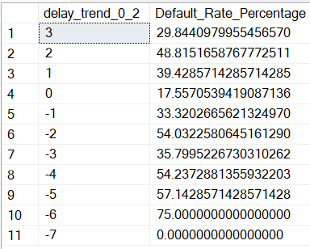

**--3 Default Rate by Utilization Category (Utilization_Category)**

SELECT

Utilization_Category,

CAST(SUM(CASE WHEN default_payment_next_month = 1 THEN 1 ELSE 0 END) AS DECIMAL(10, 4)) * 100.0 / COUNT(ID) AS Default_Rate_Percentage

FROM

Cleaned_Data

GROUP BY

Utilization_Category

ORDER BY

Utilization_Category ;

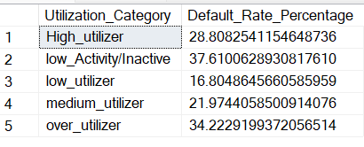

**-- 4 Default Rate by Repayment Category**

SELECT

Repayment_Category,

CAST(SUM(CASE WHEN default_payment_next_month = 1 THEN 1 ELSE 0 END) AS DECIMAL(10, 4)) * 100.0 / COUNT(ID) AS Default_Rate_Percentage

FROM

Cleaned_Data

GROUP BY

Repayment_Category

ORDER BY

Repayment_Category;

